Unit 6 Day 9

What do you know about weather?

I know that the weather can be cold.

Read this poem, it is called Watching the Weather

I see big, dark clouds today.

I think that we will get rain.

I see a bright sun outside. I think we’ll be hot tonight!

I see snow fall from the sky.

I think we’ll have a snowball fight!

The weather is different every month of the year.

We can have snowy, sunny, rainy, and cloudy weather.

Snowy Sunny



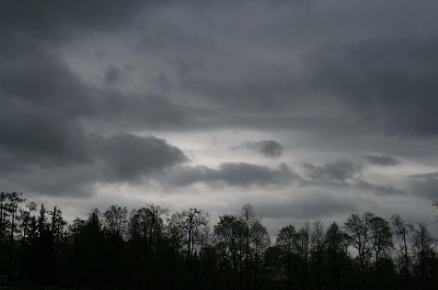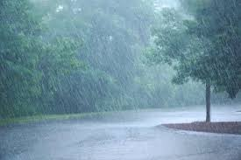 Rainy Cloudy

When we classify things into groups, you can organize the groups by details, too.

Read this passage, it is called Hot Fun, Cold Fun

When the weather is **hot**, I like to go swimming. I also like to play outside with my friends. When the weather is **cold**, I like to go sledding and build a snowman! When the weather is **cool,** I play at the park, and when it is **warm**, I ride my bike all day long!

Let’s classify hot, cold, cool, and warm into different groups based on the different activities the passage mentions. Topic: What We Do in Different Weather.

Activities! You are welcome to do all of these activities but please do at least three of them.

1. Have your child draw the 4 different types of weather we discussed above (snowy, sunny, rainy, cloudy).
2. Have your child write about their favorite type of weather. There should be at least 3 sentences explaining their favorite type of weather and why they like it. They might a visual, so discuss it together, write down 3 sentences explaining their favorite weather and then let them copy it.
3. Have your child create a chart, like above, and have them write the different activities they do when it is hot, cold, cool, and warm.
4. Have your child pick their favorite activity to do during their favorite type of weather and have them draw a picture of them doing the activity.
5. Have your child practice these simple sight words 5 times each (sit, gave, because, upon, don’t). This means to say the word, have the child say the word, and write the word.